Project Design Phase-II
Data Flow Diagram & User Stories

Date | 31 October 2026
Team ID | NA
Project Name | Electric Vehicle Market Performance & Insights
Maximum Marks | 4 Marks

Data Flow Diagrams:
A Data Flow Diagram (DFD) is a traditional visual representation of the information flows within a system. A neat and clear DFD can depict the right amount of the system requirement graphically. It shows how data enters and leaves the system, what changes the information, and where data is stored.
DFD Symbol Legend
Symbol | Name | Description
Oval / Rounded  shape | External Entity | A person, organization, or system outside the project that sends or receives data (e.g., Customer, Payment Gateway).
Rectangle with  numbered header | Process | An activity that transforms incoming data into outgoing data (e.g., Validate Request, Process Order).
Rectangle (solid fill, no number) | Data Store | A place where data is held for later use (e.g., Customer Database, Inventory).
Labeled arrow | Data Flow | The movement of data between entities, processes, and data stores, labeled with what data is being passed.

Data Flow Diagram (Level 1):
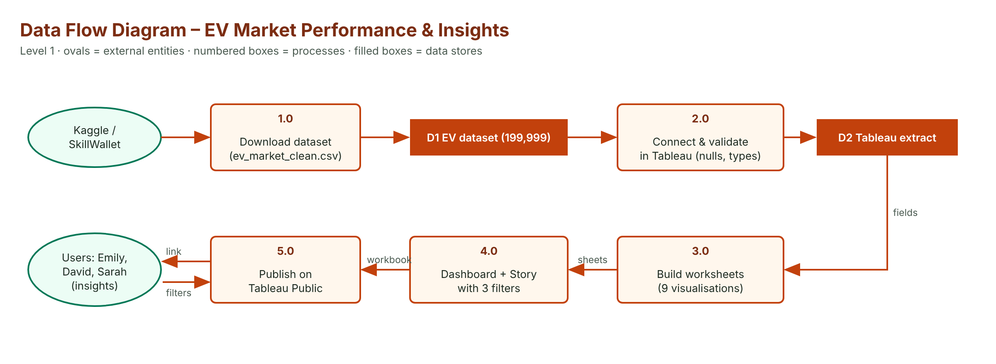

User Stories
Use the below template to list all the user stories for the product.
User Type | Functional Requirement (Epic) | User Story Number | User Story / Task | Acceptance criteria | Priority | Release
Strategy Director (Emily) | KPIs | USN-1 | As a strategy director, I can see headline sales and technical KPIs. | 6 KPIs shown and filterable | High | Sprint-2
 | Battery Size | USN-2 | As a strategy director, I can compare battery capacity by category. | Sorted bar chart | High | Sprint-2
 | Trend | USN-3 | As a strategy director, I can see sales trends for each region. | Line chart by model year | Medium | Sprint-2
BI Manager (David) | Regions | USN-4 | As a BI manager, I can see each region's share of sales. | Treemap of 7 regions | High | Sprint-2
 | Battery × Region | USN-5 | As a BI manager, I can see battery-type sales in each region. | Heatmap | High | Sprint-2
 | Drivetrain | USN-6 | As a BI manager, I can compare motor power by drivetrain. | Bar chart AWD/FWD/RWD | Medium | Sprint-3
 | Cost | USN-7 | As a BI manager, I can relate price to insurance cost. | Scatter by category | Medium | Sprint-3
Researcher (Sarah) | Efficiency | USN-8 | As a researcher, I can compare energy use per km by category. | Bar chart Wh/km | High | Sprint-2
 | Charging | USN-9 | As a researcher, I can compare AC charging time by battery type. | Bar chart by chemistry | High | Sprint-3
 | Story | USN-10 | As a researcher, I can follow a story of the main findings. | 3-point story published | Medium | Sprint-3
All users | Filters | USN-11 | As a user, I can filter by region, category and model year. | All sheets respond | High | Sprint-3
Analyst (Developer) | Publishing | USN-12 | As an analyst, I can publish the dashboard and story online. | Public links work | High | Sprint-4

